**Name :-*Shreyas Mahesh Dambe***

**Collage Name:-*Sinhgad Institute of Management and Computer Application,pune (MCA-II)***

**Internship*:- PHN Technology***

***___________________________________________________________________________***

**Web Development Task 3**

You are required to prepare a home page for an E-Commerce Online Shopping Website using HTML and CSS. In this task, you need to use CSS inside HTML and do not create an external CSS file. You should include the following headlines**: "Electronics," "Clothing," "Footwear," "Furniture,"** Within the above section, include all the products like brands offered by the Website . You should use internal styling to apply the necessary styles to your HTML elements.In this You can do both Styling no barrier for styling After completing the task, you need to copy the code and convert it into a PDF.

**Source Code:-**

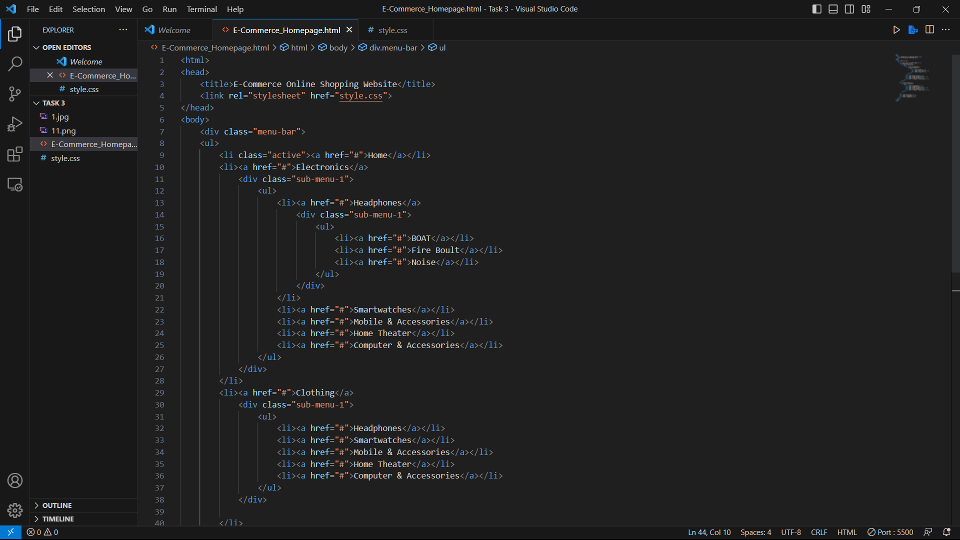

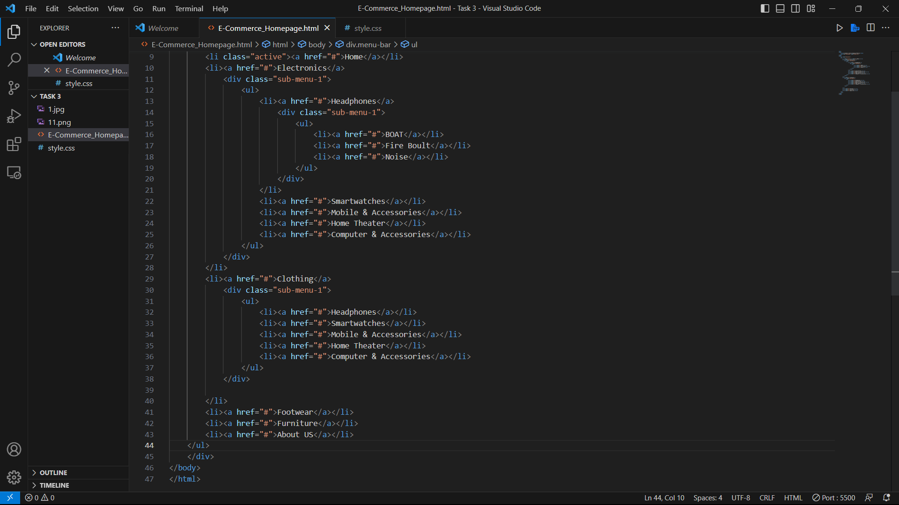

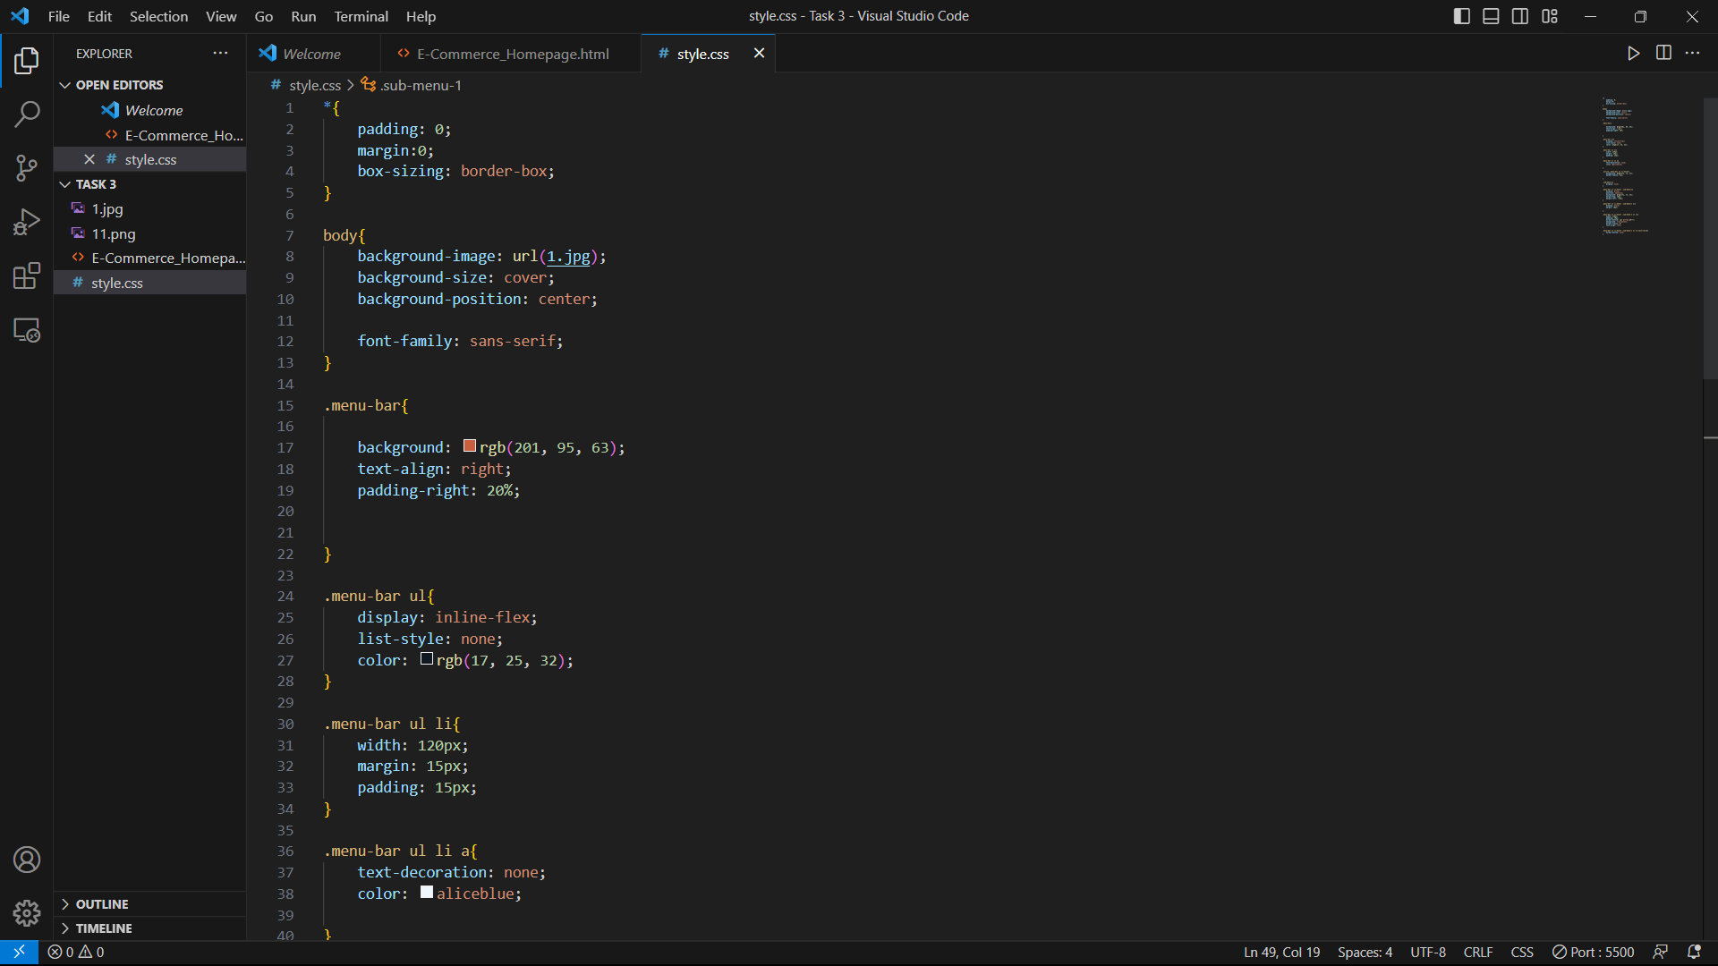

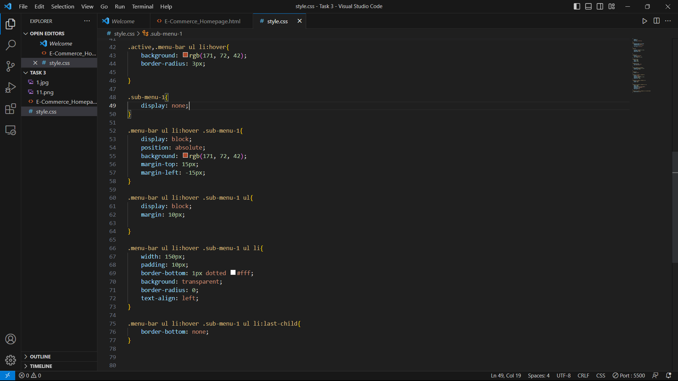

**Homepage Design**

